What foods do we recommend?
Our top 2 choices for non-prescription pet foods
are:
Hill’s Science Diet
- Complete, Balanced Diet
- Multiple formulas to fit each pets needs

Diets:
- Science Diet Healthy Advantage
- Science Diet Ideal Balance
- Science Diet

Also available in large breed formulas, Light formulas, Senior diets, puppy and Adult Maintenance, and feline diets

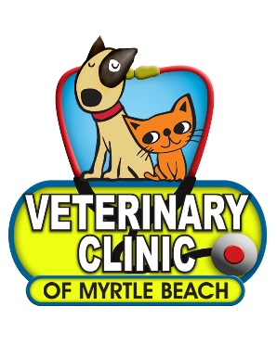
These diets are among our top recommended diets because they are formulated by Veterinary Nutritionists to meet your pets needs. They have the vitamins and minerals needed for complete nutritional care for your pet.

Purina
- Complete, Balanced diet
- Multiple formulas to fit each pets needs

Diets:
- Purina Proplan
- Purina One

Also available in large breed formulas, Light formulas, Senior diets, puppy and Adult Maintenance, and feline diets

